# **08969 Group 13 game report**

## 1.1 High concept

The high concept of our game is a minimalistic, gravity swapping, reaction game that uses the idea of inverting gravity to challenge players more and more as they progress.

## 1.2 Emotional aesthetic

The game itself appears very simple in its art style, we utilise a monotone palate, which provides the game with a clear cut, focused look. This draws more focus from the player to the overall gameplay, which in turn allows the player to become more engaged in the play rather than distracted by an obnoxious colour style that doesn't befit the games’ style.

To introduce the player to a more varied scheme, the colour scheme inverts along with the gravity (see 1.3 Mechanics and Dynamics Implemented)

Above, The colour scheme inverts when the gravity is swapped.

Using this idea of “inverting” everything on the screen is our way of signifying to the player that a change has been made, and therefore a change t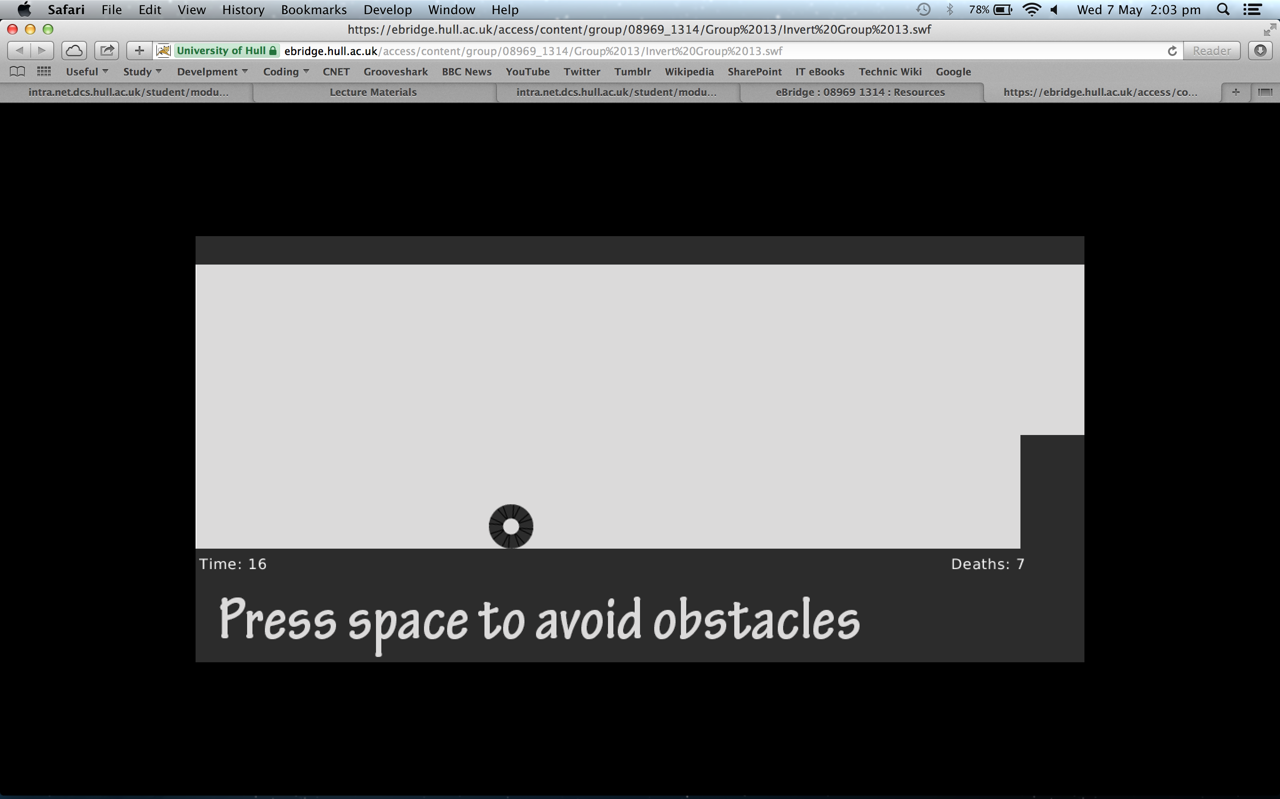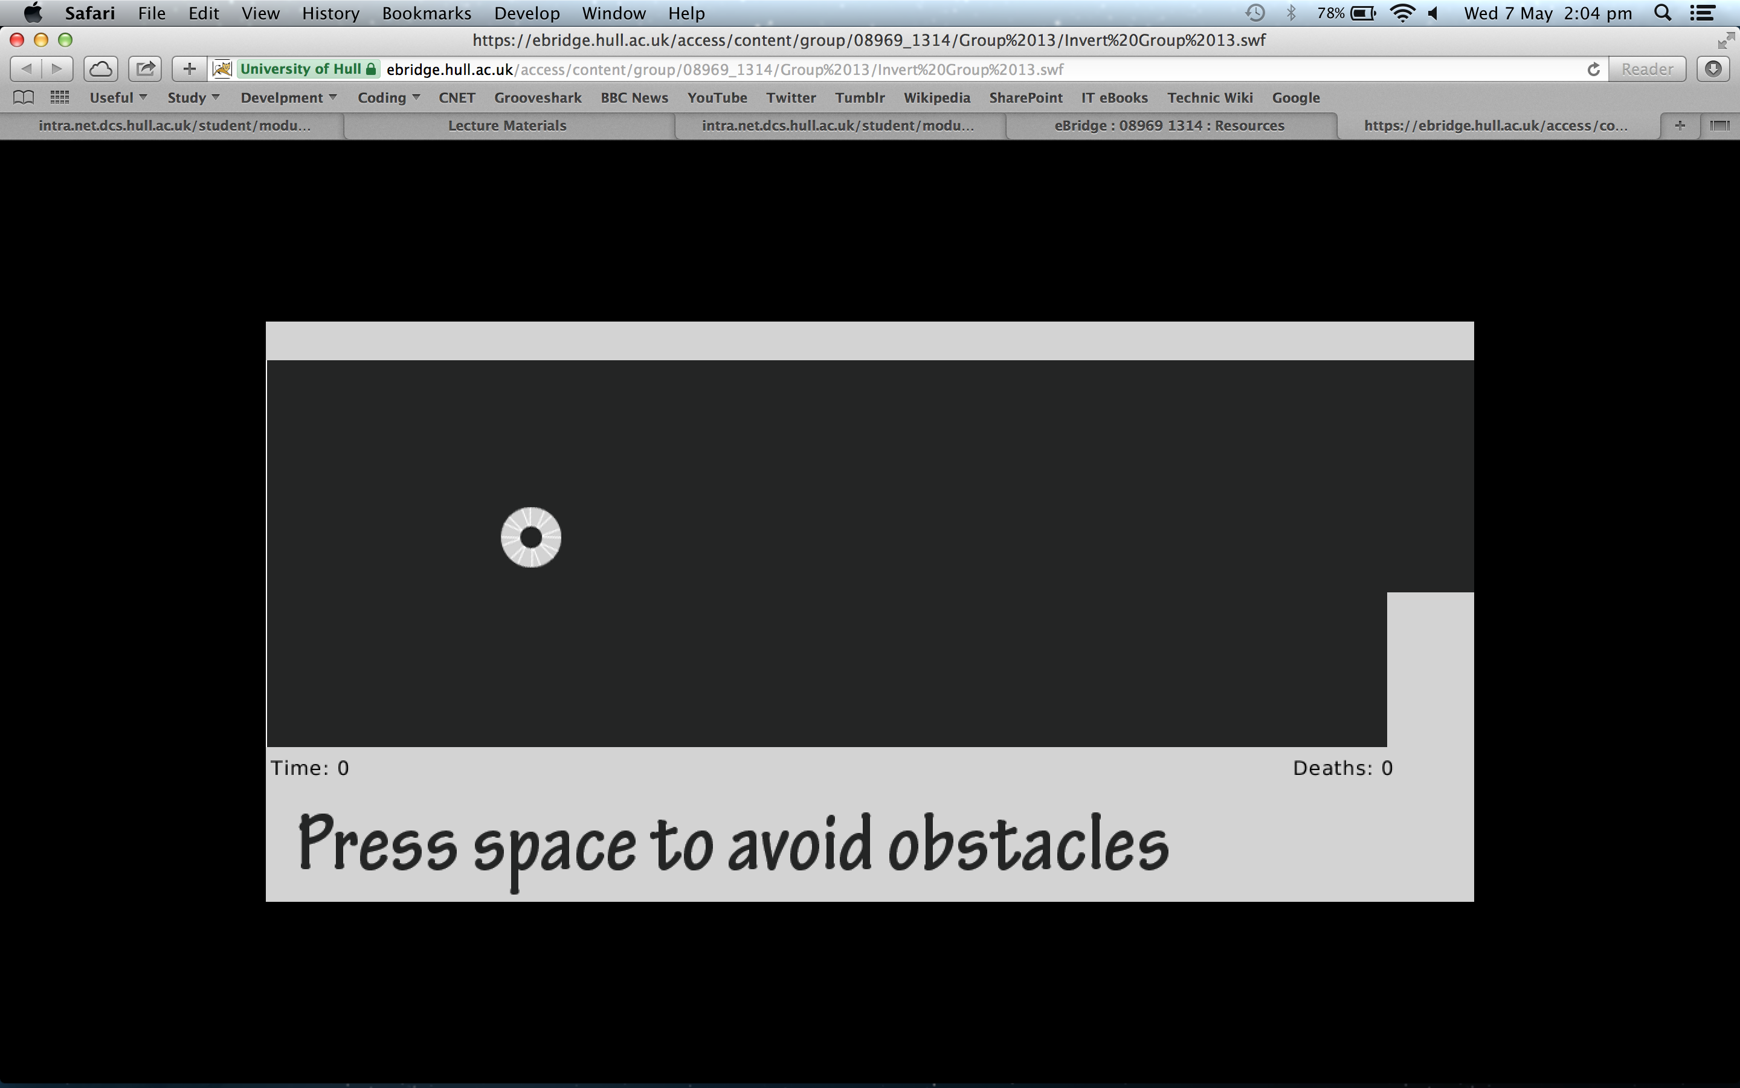o the game has been made, in a way that combines the art style with the overall theme of the game.

We use a character which isn’t even human in its appearance, which maintains a blank slate, allowing the player to anthropomorphise and apply their own feeling or personality to the character. It also allows the player to feel more connected to the game, as though *they* are playing the game, not by proxy with a character, so when we use the text at the bottom of the screen to guide the player, they feel as though it’s being directed at them.

We wanted the player to feel good during the early levels of the game as it is very easy to begin with, this gives the player a sense of success as they complete each level with relatively little effort. However the difficulty sharply increases as each level is progressed thus forcing the player to commit more time to beating the level, and therefore after each level the sense of victory is much improved.

## 1.3 Mechanics and Dynamics Implemented

We utilise a variety of different mechanics across the games levels to keep the player engaged and challenged as they progress. This is both to ensure they continue enjoying the game, and also to combat the players’ improving skill, as they will gradually improve as they complete more levels and become accustomed to a mechanic, we then throw a new mechanic into the mix to add a new challenging element to the gameplay.

**1.3.1 Introducing new Mechanics**

It is important that when we introduce a new mechanic, we only introduce one mechanic for the player to learn at a time, and also that the particular level they are on can only be completed by using the new mechanic. Thus forcing the player to use it and therefore learn it. This allows us to throw new mechanics in latte levels without having to ensure the player understands the old ones.

**1.3.2 Progressing the levels**

We force the player to make progress by having their character always moving along the level to the right, but we also use the text at the bottom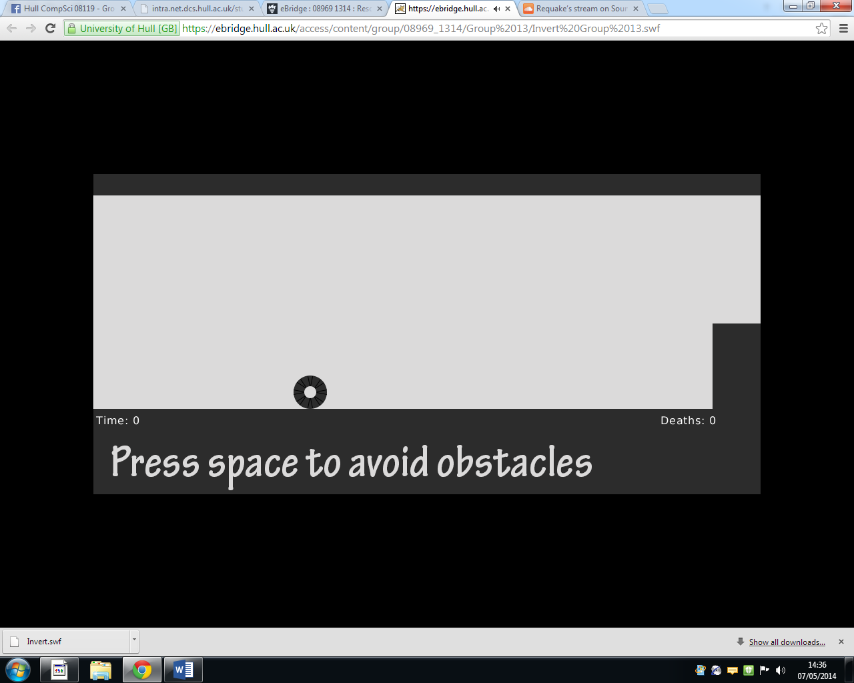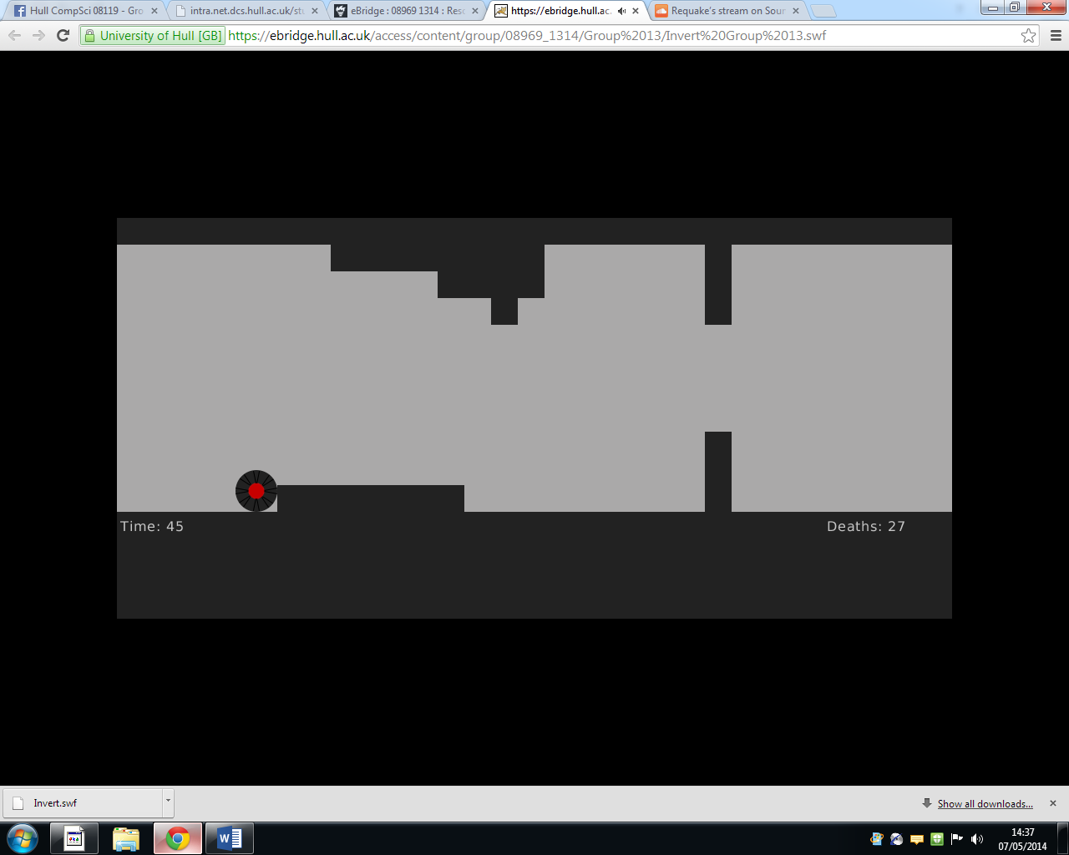 of each level to make the player feel like they are part of an interaction with the game, as the text guides the player in their game.

As the player is constantly moving to the right, they have to use the space bar to ‘Invert’ the gravity in order to avoid obstacles and get to the end of the level.

**1.3.3 Implemented Mechanics**

Inverting the gravity is the most prominent gameplay mechanic, and is involved in every level multiple times. When the player presses the space bar, the gravity inverts and the player ‘falls’ up, and can therefore avoid barriers and other obstacles in their path.

If the player hits an obstacle then the player will die and have to restart the level. The player character will also glow red inside of the shape.

Above left: Alive. Above Right: Dead.

The blue gate: this slows the player’s movement for a few seconds, if the player doesn't expect it then it can throw off their timing, increasing the difficulty. Decreasing the speed momentarily also means that we could squeeze difficult sections of a level into a more compact area increasing the difficulty still. This changes the flow of the game which can keep the players attention and also allows us as level developers.

The green gate: This gate speeds the player up for a few seconds, as with the blue gate, this can throw the player off, again adding another difficulty increase and keeping the player attention

Moving platforms: at around the halfway point of the game, moving platforms will appear, the challenge with these is that you have to predict where they will be when you reach them to see whether you must try and avoid them. This addition makes sure that players are even more alert as they will have to hope they get it on the first try but after it forces them to watch out for this sort of thing and remember when and where they will appear and need to be.

Red tiles: The last obstacle that appears is the red tile (really just a sideways gate). The player must avoid these like any of the other structures they have encountered.

## 1.4 Reflective summary

Overall we are very happy with how our game turned out. We feel that the “invert” mechanic works well to offset the minimalistic art style. If we were to take this game on again, we would definitely add voice acting along with the on screen text, to add a greater sense of purpose along with a narrative. This would also allow realistically the text on screen to be a visual cue along with the sound of someone narrating their progress.

It can possibly be too much to expect the player to pay full attention to both the game and the text.

Through playing a prototype version of our game, we have come to the conclusion that the game should include a checkpoint system, this is due to some of the levels containing more than one ing section with a particularly difficult obstacle. Therefore a checkpoint system would allow the level to maintain difficulty, without becoming prohibitively difficult to the extent the player simply gives up.

## Appendix A: Assets

## Creative commons assets used.

Main theme song: Herr Doktor - Revenge

(<http://freemusicarchive.org/music/Herr_Doktor/199X/06_herr_doktor_-_revenge>)

All artwork assets and level components were created in Stencyl and are therefore not subject to copyright violations.